ADIYAMAN UNIVERSITY
VOCATIONAL SCHOOL OF TECHNICAL SCIENCES DEPARTMENT OF ELECTRICITY AND ENERGY
OUR MISSION
We want to educate an electrical technician with international quality, who is knowledgeable in the field of Electricity and Energy, who has problem-solving skills, who is entrepreneurial, constantly renews himself, who aims to learn throughout life, and who can produce the most appropriate solutions by using his resources, time, economic power and workforce most effectively.
In addition, the technician who have adopted the national values of the country, have learned scientific thinking and research techniques, have professional ethical values well, have good field knowledge, have general knowledge and culture in all fields of electricity and energy, have high self-confidence, have specialized programs and work that requires expertise and design in their field. To train students who are candidates for immediate employment in their branches; To become a pioneer and leading department that has reached the competence to meet the knowledge and expertise needs of the country's industry, especially in the Southeastern Anatolia Region, in the field of electrical engineering and to contribute to its development.
OUR VISION
To be a technician who has received sufficient training to produce effective and valid solutions to the problems they encounter in the field of Electricity and Energy, who can think analytically to use the information they have, who is a researcher, who is prone to teamwork, who fulfills their responsibilities, who aims beyond their time, and who can transition to engineering with YGS. We aim to be among the most respected and preferred departments in our country and the Southeastern geography, with its contributions in the scientific, technological, industrial, and social fields in Electricity and Energy.
OUR DEPARTMENT

Dear students,
You have successfully completed the preparation for university and the subsequent challenging exam. I congratulate you for your dedication and efforts. I hope you were rewarded for your efforts. Welcome to Adıyaman University and the Department of Electricity and Energy, where your future will be shaped.
We aimed to train technical personnel who are familiar with the systems and equipment containing electricity, analog-digital electronics, microcomputers, and automation elements used in the industry, who know their properties, who can apply their knowledge to industrial systems and equipment, who can perform maintenance and repairs, and who can use programmable devices. We can define electricity as controlling equipment and production using

electrical and electronic circuit systems. The training program offered has been prepared by combining many years of experience with the requirements of modern technology. In this program, which has a wide range of job opportunities, students; basic principles of electricity, installation, maintenance and repair of electrical equipment, using measuring instruments, using computers and CAD/CAM and similar programs used in industry, drawing and reading electrical circuit diagrams with computers, how industrial machines are controlled electronically with computers, when necessary. They learn to carry out maintenance and repair, prepare technical reports, prepare projects, and ensure the safety of the workplace and personnel at the operating table.
EXAMPLES OF EDUCATION AND TEACHING METHODS
- Lessons & In-Class Activities
- Teamwork
- Laboratory
- Read
- Homework
- Preparing project
- Seminar
- Internship
- Technical tour
- Web-Based Learning
- APPLICATION
- On-Site Application
- Professional Activity
- Social activities
- Field Study

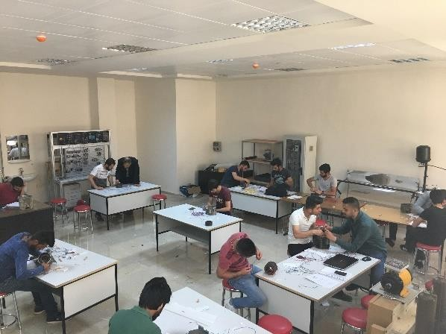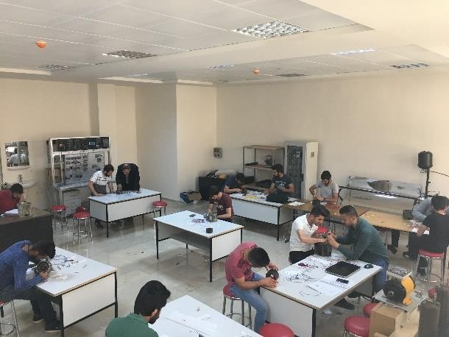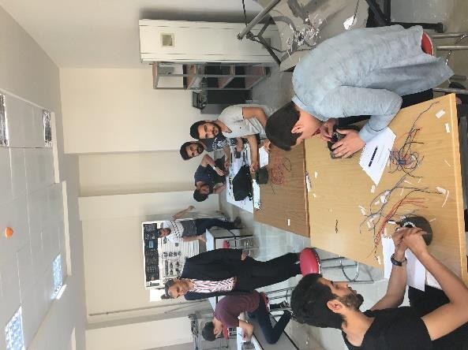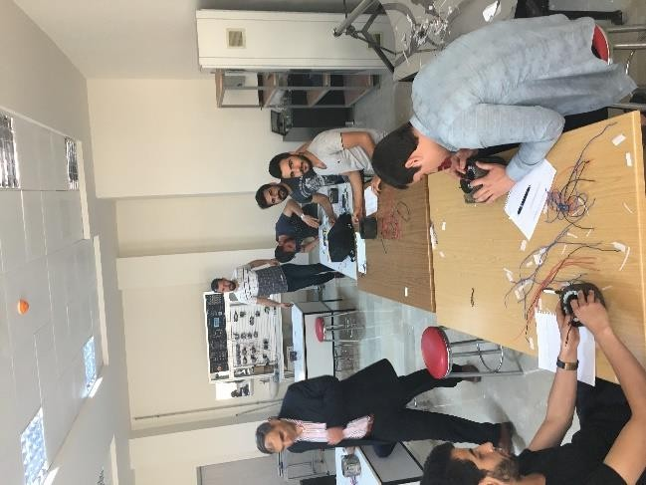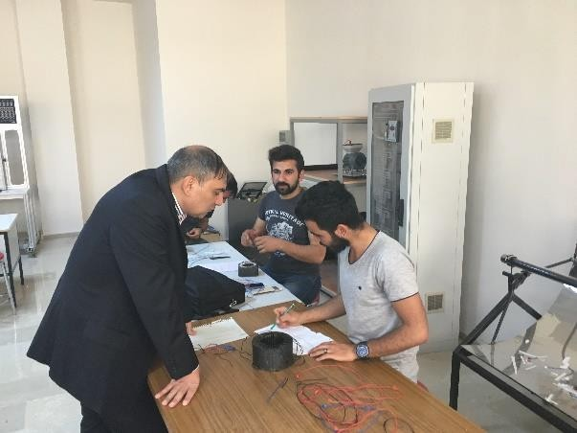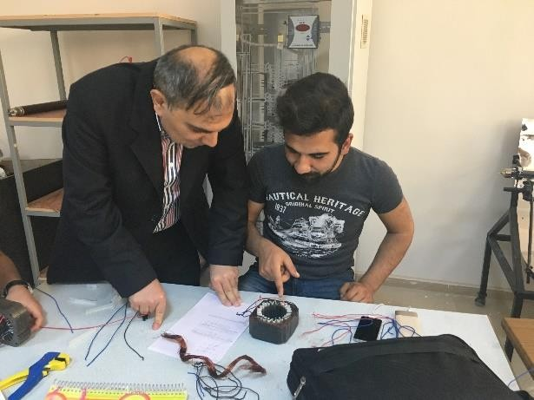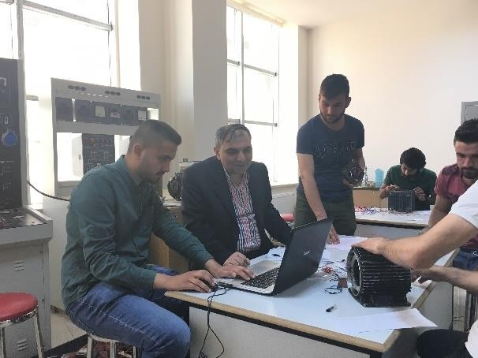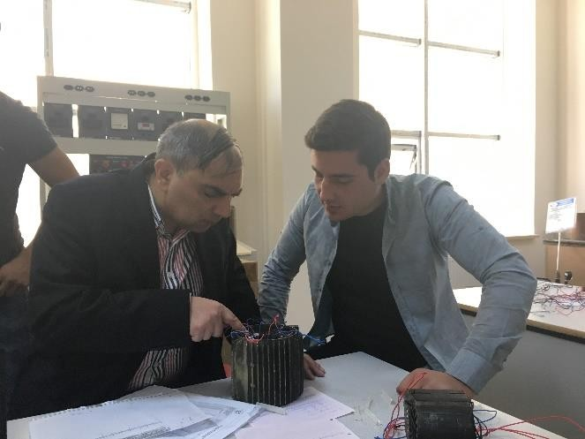

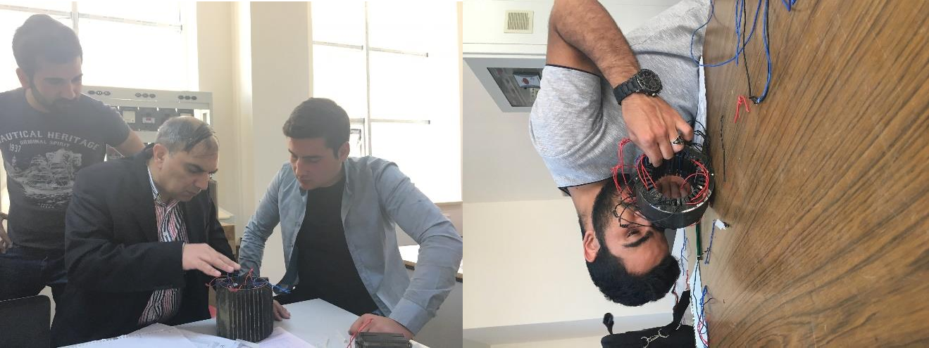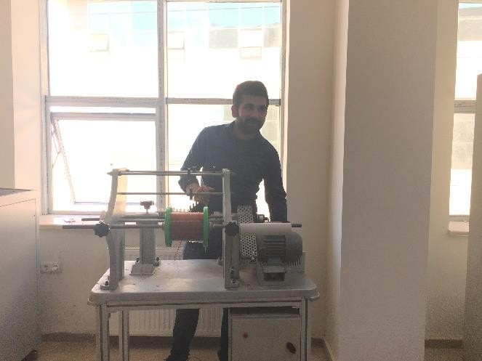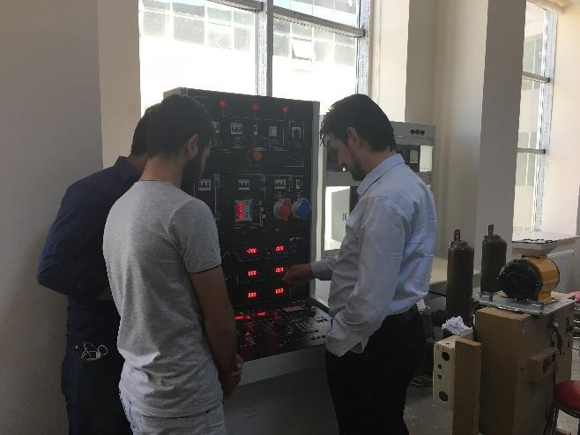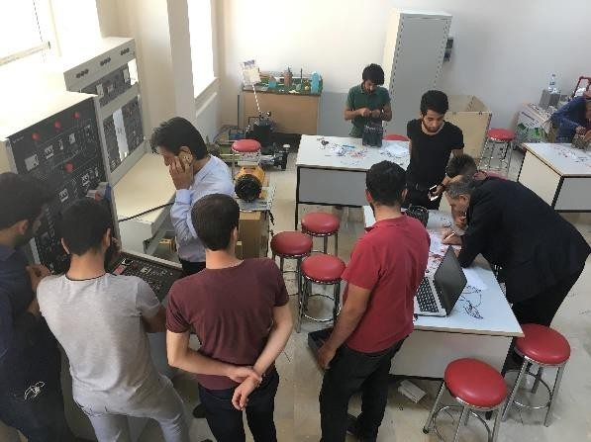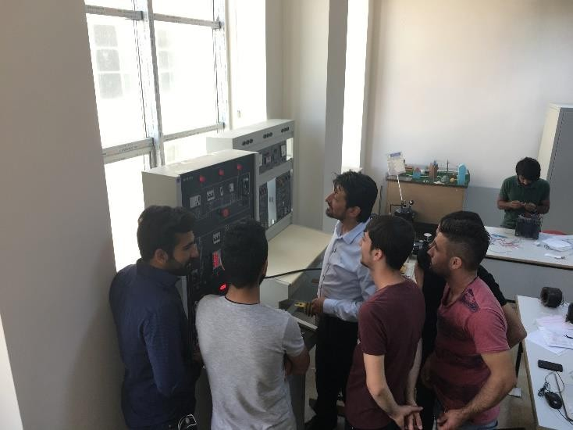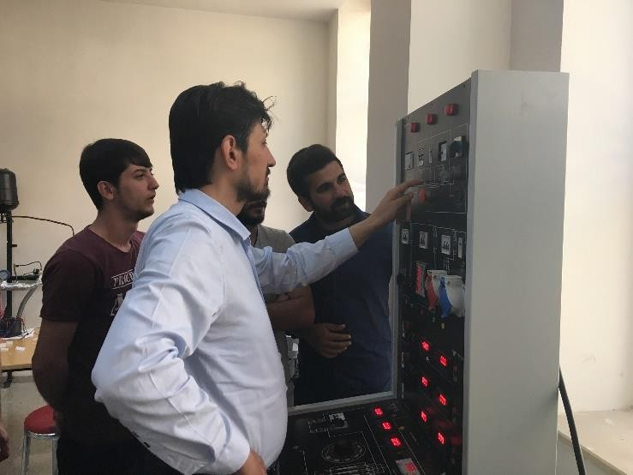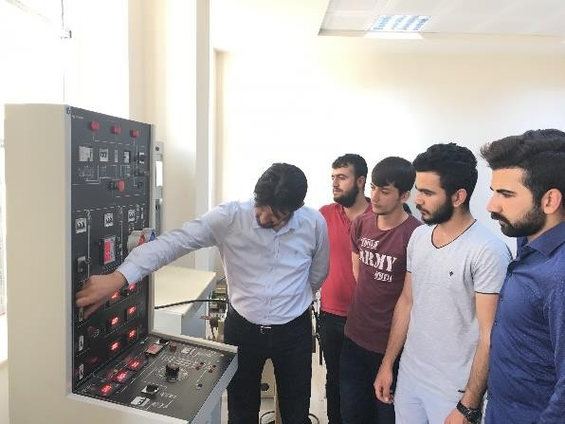

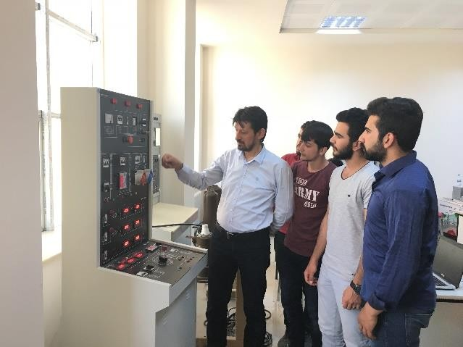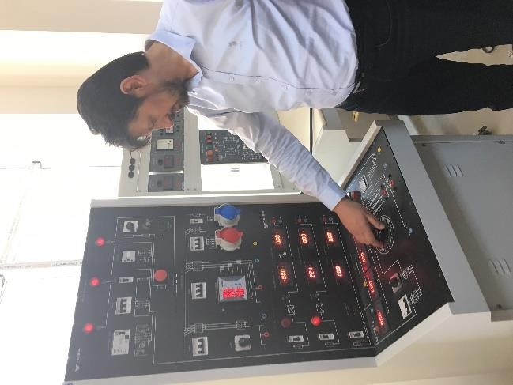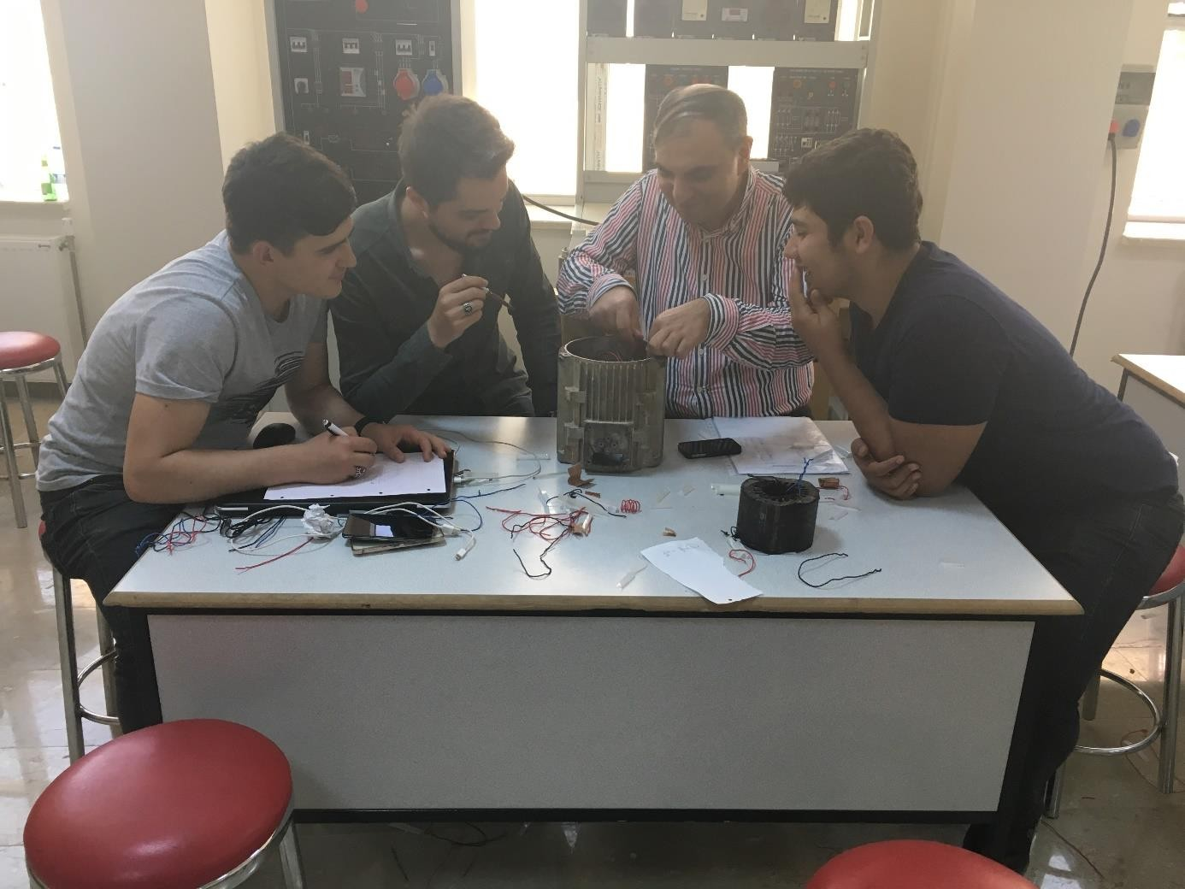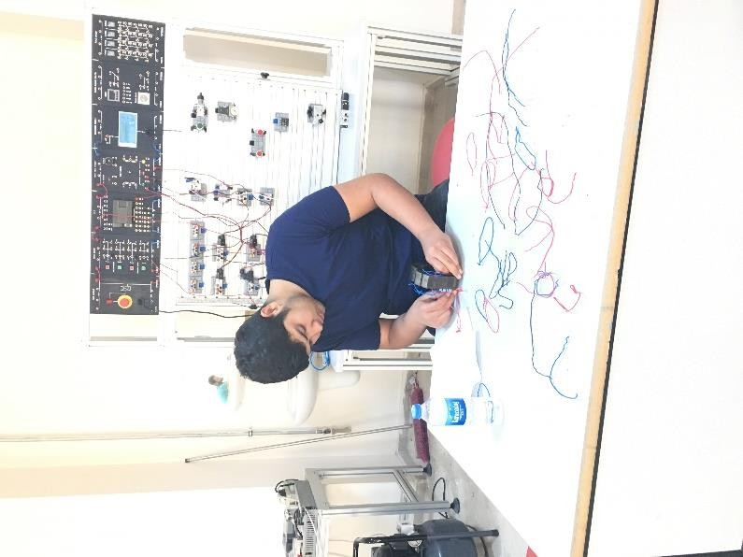

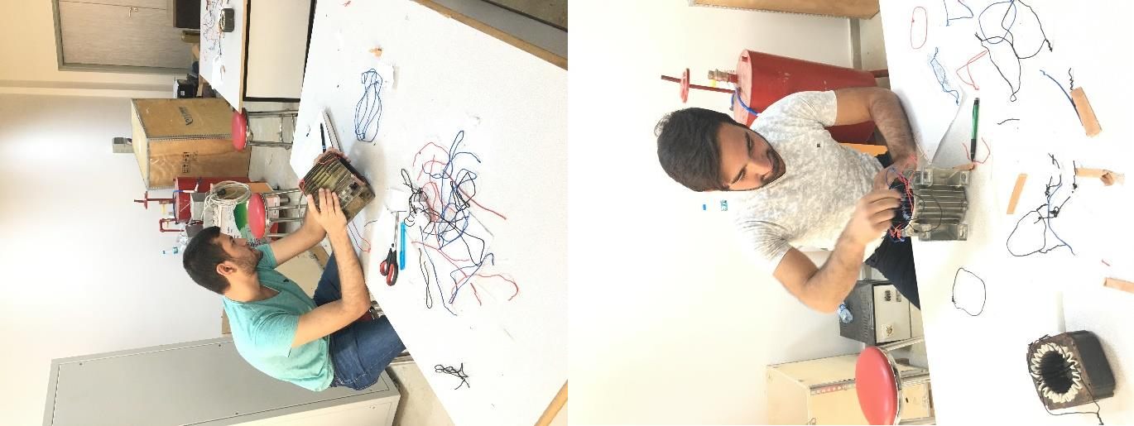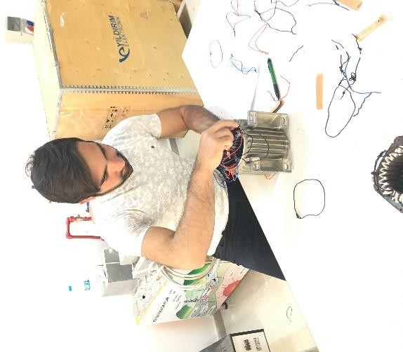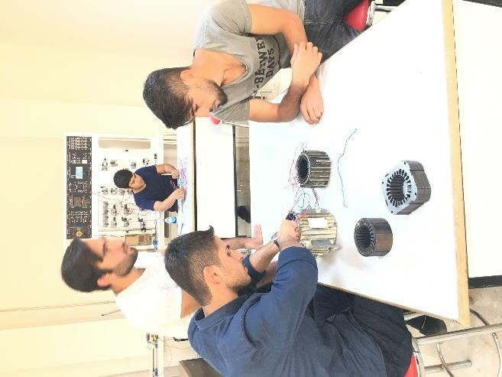

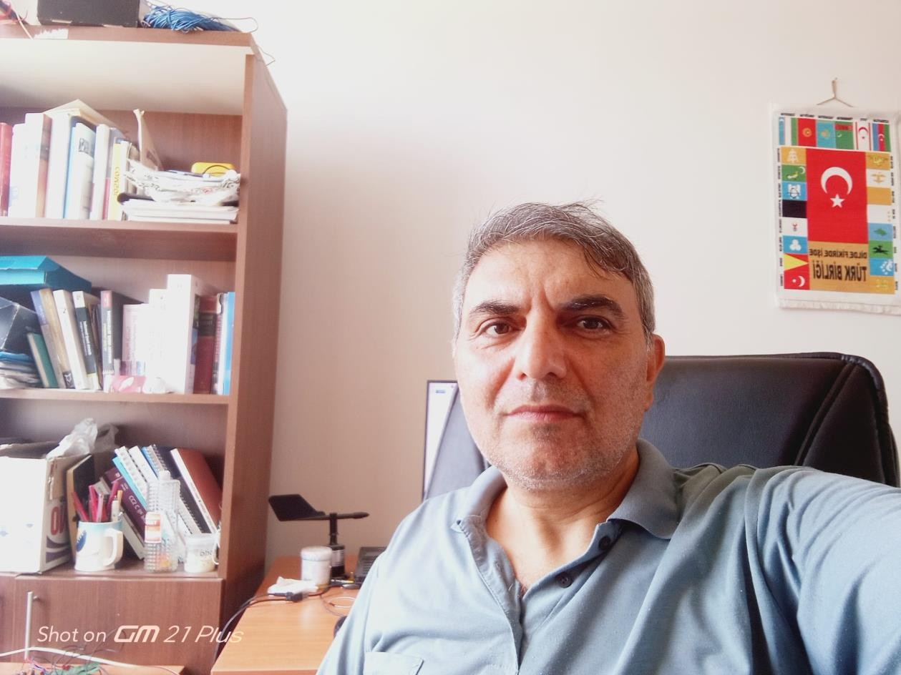
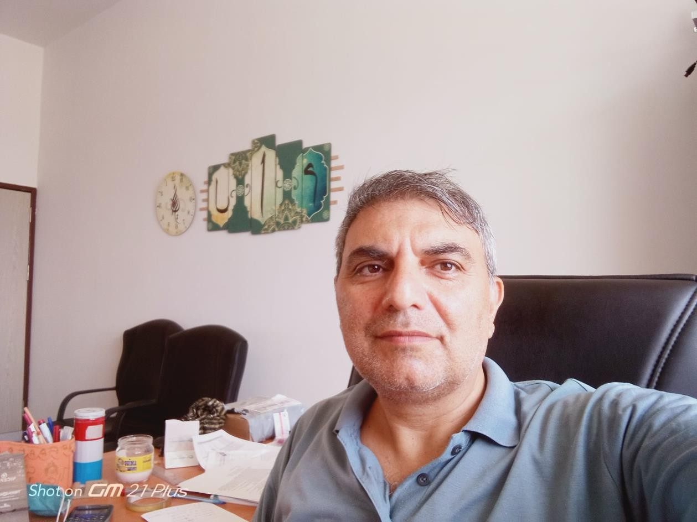
Assoc.Prof. Dr. Hacı SOĞUKPINAR (Head of Department)

Assist.Prof. Dr. M. Fatih AYDIN
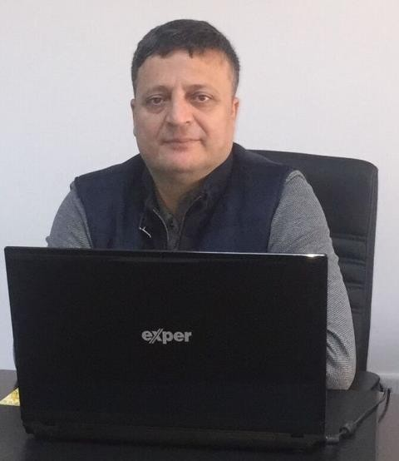

Assist.Prof. Dr. Mehtap DEMİR.
