
Research Spaces
Partner & Agent Training Guide
How the new Research Space works, what to demonstrate, and what to promise
Version 1.0 · September 2026

Contents
Contents 2
1. What a Research Space is 3
What goes into a space 3
2. What is new in this version 4
3. The interface, screen by screen 5
3.1 The Research Spaces list 5
3.2 Inside a space 5
4. Creating a space and adding sources 7
4.1 Create the space 7
4.2 Five ways to add sources 7
4.3 Importing a reference library 8
5. Asking questions in chat 9
5.1 The three input shortcuts 9
5.2 Controlling what the AI reads 9
5.3 What good answers look like 9
5.4 Chats are saved 9
6. The agents 10
6.1 Agent reference 11
6.2 Stages 6 and 7 — and what we do not do 11
6.3 Which agents to demonstrate 13
7. Trust signals 14
7.1 Citations on every claim 14
7.2 Paper quality badges 14
7.3 Stated limits 14
8. A ten-minute demonstration 15
9. What not to promise 16
10. Questions you will be asked 17
11. Quick reference 18
One-line description 18
The seven stages 18
The three points that close the sale 18
The three things not to promise 18

1. What a Research Space is
A Research Space is a working area that holds a set of sources the researcher has chosen, together with a set of tools that work on those sources.
The distinction that matters in every conversation you will have about this product is simple:
- SCiNiTO Search looks across the whole literature — 500 million works.
- A Research Space works on the papers the researcher put into it, and every answer cites them.
A researcher might have one space per chapter, one per systematic review, one per grant application, or one per reading group. Spaces are independent of each other.
Say it like this: “Search is how you find papers. A Research Space is where you work with the ones you kept.”

What goes into a space
Source type | What it means
Papers | Records added from SCiNiTO Search, from My Library, or found by an agent. Most carry abstract-level detail; open-access papers can be read in full.
PDFs | Files the researcher uploads. PDF is the only upload format supported at this stage. Uploaded PDFs are always read in full, so answers drawn from them are the most detailed.
Notes | The researcher's own text — ideas, meeting notes, supervisor comments.
Artifacts | Results the researcher chose to keep. Pressing Save on an agent's answer files it in the Sources panel as an artifact, so later work can build on it.

Important for demos: an uploaded PDF is read in full. A bookmarked paper is usually read at abstract level unless it is open access. Expect this question from librarians and answer it plainly — it is a strength, not a weakness, that the system tells the user which is which.

2. What is new in this version
If you have demonstrated Research Spaces before, these are the changes to lead with.
New | Why it matters to the customer
Agents by research stage | Seven named stages from Scope to Write, each with agents that do one job. The workflow is visible, not hidden behind a chat box.
Import references (RIS) | A whole Mendeley, Zotero or EndNote library can be brought in at once, instead of adding papers one at a time.
Persistent chats | Conversations are saved inside the space and can be reopened. Work carries across sessions.
Manage members | Spaces can be shared with colleagues. Relevant for labs, supervisors and research groups.
Source selection | Checkboxes on each source let the researcher narrow the context to a subset instead of always using every source.
Trust badges | Papers carry NOT REVIEWED and CONCERN flags where applicable, so a preprint or a flagged record is visible at a glance.
Beyond-space marking | Agents that search the wider literature are labelled “searches beyond this space” on their card, so the researcher always knows where an answer came from.

Coming soon — do not promise: Connect Zotero (direct collection sync) is marked Coming Soon in the interface. RIS import is available now and covers the same need. Do not present Zotero sync as available.

3. The interface, screen by screen

3.1 The Research Spaces list
The landing screen shows every space the researcher owns or has been invited to.
- All Spaces — the total count, top left.
- My Library — papers the researcher saved but has not yet placed in any space.
- Recent — a quick list down the left side.
- Each space card shows three counts: papers, notes, and artifacts.
- + Space — creates a new space. Search and sort controls sit alongside it.
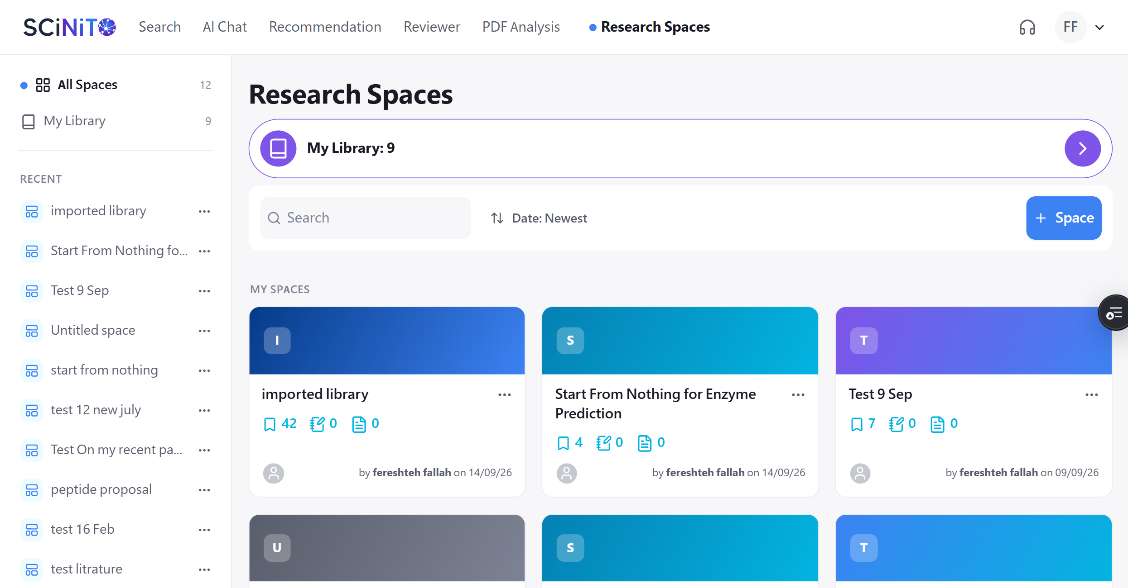
Figure 1 — The Research Spaces list. Each card shows the number of papers, notes and artifacts in that space.

3.2 Inside a space
The space screen has two panels.

Left panel — Sources and Chats
- Sources tab: everything in the space, with filters for All, Papers and Artifacts.
- A checkbox sits beside each source. Ticking a subset narrows what the AI will use.
- Search this space finds a source by title or author.
- Chats tab: every saved conversation in this space. Chats stay in the space; opening one resumes where the researcher left off.

Right panel — Chat and Agents
- Chat: ask questions in plain language. Every answer cites the sources it used.
- Agents: the seven research stages, each with its own tools.
- Context: all sources (n) — the indicator at top right showing how many sources the AI is currently working from.

Header
- Space name and description — both editable.
- Manage members — invite colleagues into the space.
- Share — share a conversation.
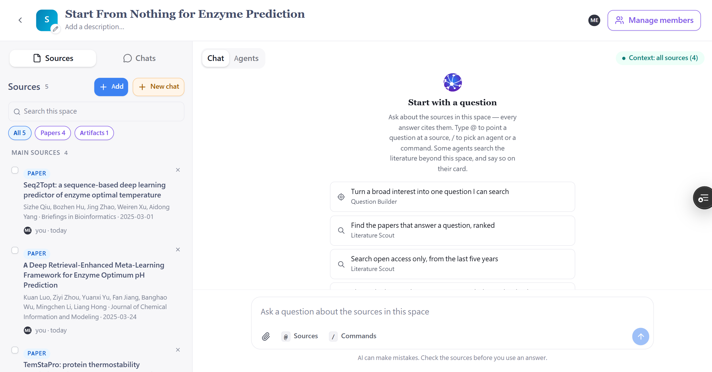
Figure 2 — Inside a space. Sources on the left with All / Papers / Artifacts filters; chat on the right, with suggested first questions and the Context indicator top right.

4. Creating a space and adding sources

4.1 Create the space
- From Research Spaces, press + Space.
- Give it a name. A project or chapter name works better than a topic — researchers will accumulate many spaces.
- Add a short description. Optional, but it helps when a space is shared.

Demo tip: create the space empty and leave it empty for a moment. The fact that a researcher can begin with nothing — no PDFs, no downloads — is the single most persuasive point in the product, and it is lost if you arrive with a pre-filled space.

4.2 Five ways to add sources
Press + Add inside the space. The dialogue offers:
Option | What it does
Search online | Searches 500 million works. Results are added straight into the space.
From My Library | Papers the researcher already saved in SCiNiTO.
Upload files | PDF only at this stage. Uploaded PDFs are read in full. Spreadsheet and data files (XLSX, CSV) are planned for a future release.
Import references | A RIS file exported from Mendeley, Zotero or EndNote. Brings an entire reference library in at once.
Add note | The researcher's own text — ideas, meeting notes, research questions.
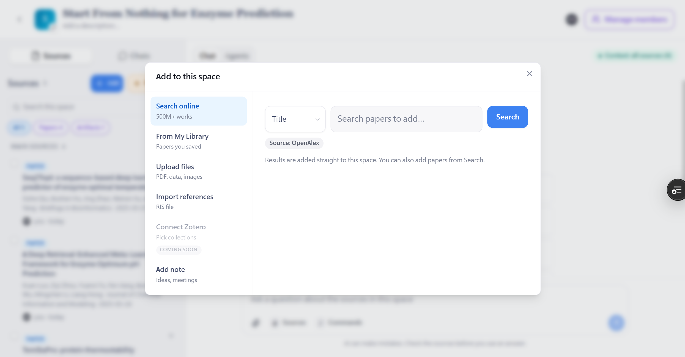
Figure 3 — The Add to this space dialogue. Note that Import references (RIS) is available; Connect Zotero is marked Coming Soon.

Uploads are PDF only for now: the dialogue lists other file types, but at this stage only PDF is supported. Spreadsheet and data files — XLSX and CSV — are planned for a future release, alongside the Data Agent that will analyse them. If a customer asks about uploading their data, say that clearly rather than letting the dialogue speak for itself.

4.3 Importing a reference library
This is the fastest route to a fully populated space and the best answer to “I already have all my papers somewhere else.”
- In Zotero: right-click the collection → Export Collection → Format: RIS → save.
- In Mendeley: select references → File → Export → RIS → save.
- In EndNote: File → Export → Output style: RefMan (RIS) Export.
- In SCiNiTO: + Add → Import references → choose the file.

Set the expectation early: a RIS file carries references, not PDFs. The researcher's annotated PDFs stay in Zotero. SCiNiTO will find full text where the paper is open access; for the rest, the PDF can be uploaded. Saying this before the customer discovers it prevents the most common disappointment with this feature.

5. Asking questions in chat
Chat answers from the sources in the space, and cites them on every claim.

5.1 The three input shortcuts
Type | What it does
@ | Point a question at one specific source. Useful when the space holds many papers and only one matters.
/ | Pick an agent or a command without leaving the message box.
Paperclip | Attach a file to the question.

5.2 Controlling what the AI reads
By default the AI uses every source in the space — shown as Context: all sources (n). To narrow it, tick the checkboxes beside the sources you want in the Sources panel. This is worth demonstrating: it is how a researcher asks a question of three papers out of forty.

5.3 What good answers look like
- Every claim carries a citation to a specific paper in the space.
- Where a paper's full text could not be retrieved, the answer says so rather than answering from the abstract.
- Where the sources do not cover the question, the answer says that too, instead of filling the gap from general knowledge.

This is the sales argument: the value is not that it answers. Every AI tool answers. The value is that it tells you where the answer came from, and tells you when it cannot answer. That is what a supervisor or a librarian needs before they will let students use a tool at all.

5.4 Chats are saved
Each conversation is stored in the space under the Chats tab and can be reopened later. A researcher can keep one chat per line of enquiry — one for methods, one for the literature review — and return to each.
Agent results inside a chat collapse into a single summary line, for example “Reading the space’s sources and finding the gaps — 5 gaps found, 4 still open”, which can be expanded to see the full working.
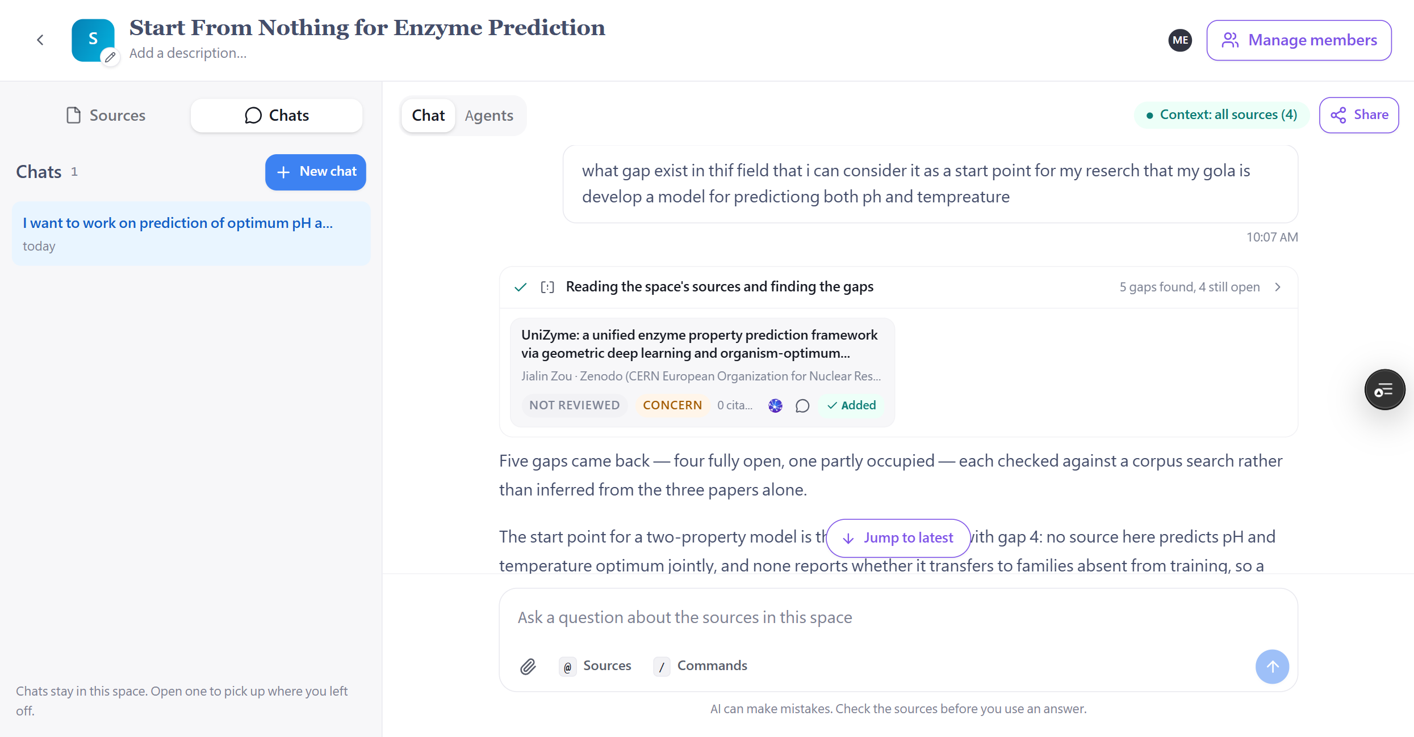
Figure 4 — A saved chat. The agent result is collapsed to one summary line, and the paper it surfaced carries NOT REVIEWED and CONCERN badges.

6. The agents
Each agent does one job and answers in chat. Results can be kept by pressing Save, which files them as an Artifact in the Sources panel.
Agents are organised by the seven stages of a research project:
1 Scope → 2 Discover → 3 Screen → 4 Read → 5 Synthesize → 6 Analyze → 7 Write
Explain the marking: agents labelled “searches beyond this space” also look at the wider literature and can bring back work the space does not hold. Chat, by contrast, answers only from the space. Point this out during a demo — it is the kind of precision that earns trust with librarians.
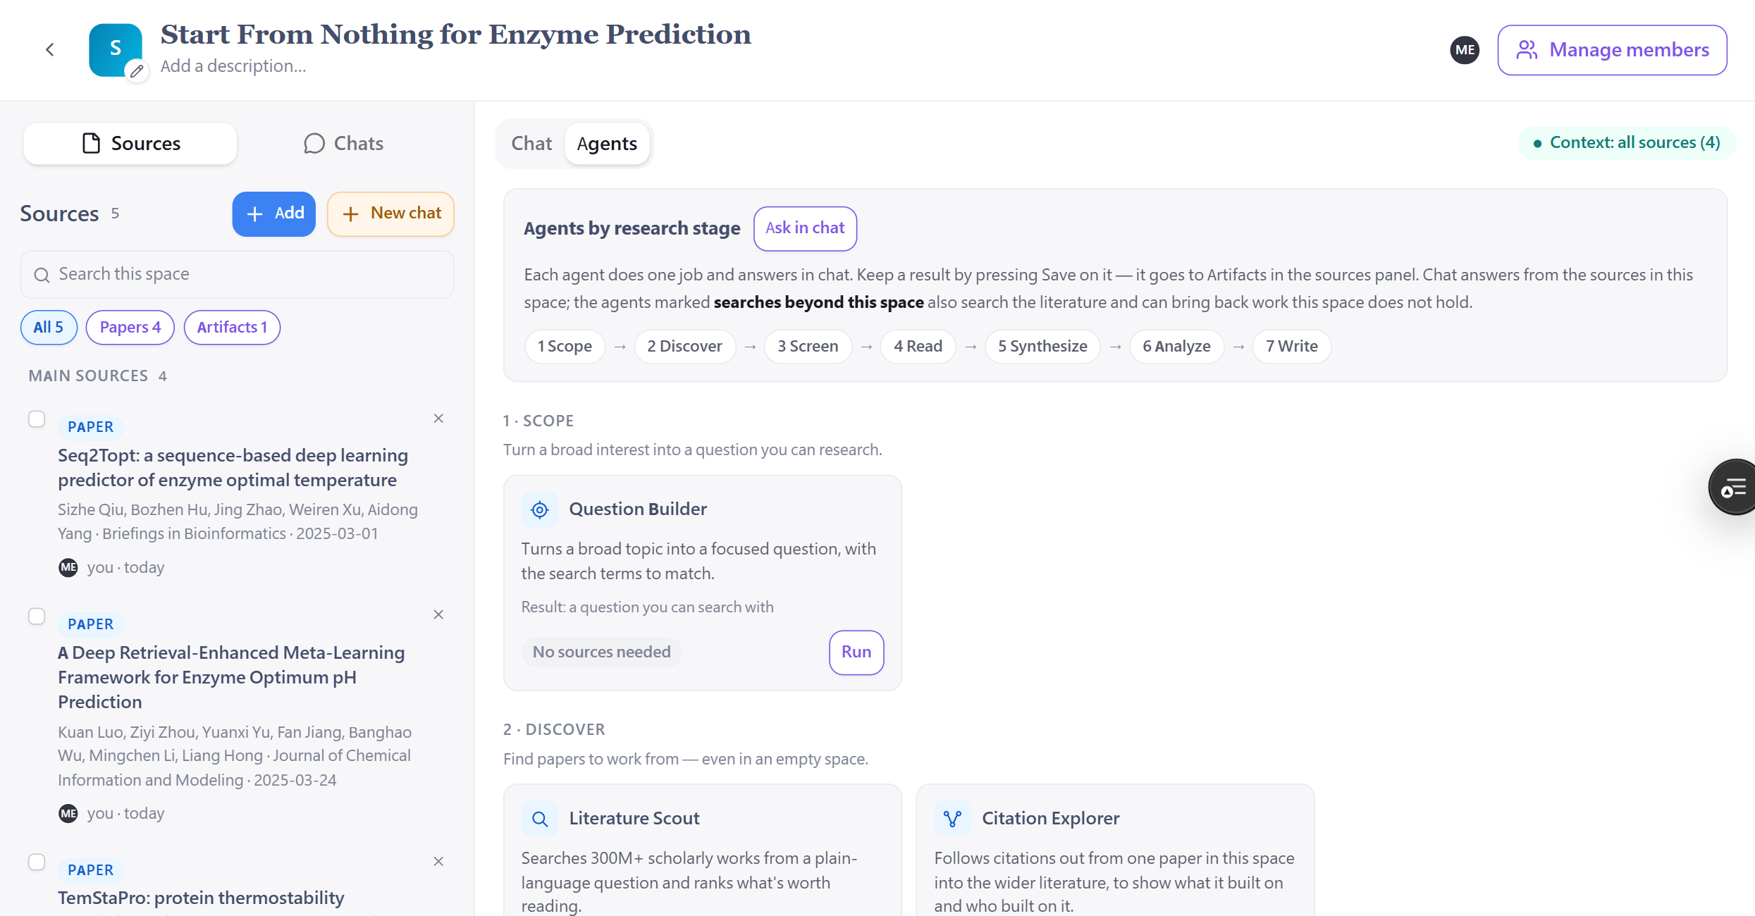
Figure 5 — The Agents tab, organised by research stage. Each card states what the agent does, what it needs, and what it returns.

6.1 Agent reference
Agent | What it does | Result
Question Builder  1 · Scope | Turns a broad topic into one focused question, with the search terms to match. Shows the assumptions it made and lets the researcher edit the question, change the terms and add limits before anything runs. | A question you can search with. No sources needed.
Literature Scout  2 · Discover | Searches 500M+ scholarly works from a plain-language question and ranks what is worth reading. Reports how many matches it searched through. | Ranked papers you can add. Searches beyond the space.
Citation Explorer  2 · Discover | Follows citations out from one paper in the space into the wider literature, showing what it built on and who built on it. | A map of the work around it. Searches beyond the space.
PRISMA Screener  3 · Screen | Writes eligibility criteria from the question, searches for records that could meet them, then screens those and the researcher's own sources against every criterion. | A PRISMA 2020 flow diagram and the decision trail behind it.
Deep Reader  4 · Read | Opens the full text of every paper named and writes each one out — what it set out to do, how and on whom, what it found with the numbers, and what the authors admit limits it — quoting the paper with page numbers throughout. | A complete reading of each paper, in its own words.
Gap Finder  5 · Synthesize | Reads the sources, finds what they leave unanswered, then searches the corpus to check whether anyone has answered it since. | Gaps, each with its evidence and what the search found.

Source requirements: each agent card states what it needs — for example “No sources needed” for Question Builder, or a minimum number of sources for agents that read across a set. An agent that cannot run yet will say why on its card.

6.2 Stages 6 and 7 — and what we do not do
Two stages are not yet available. Analyze and Write are in build and arrive in a future release. Because the seventh stage is called Write, agents are asked about it constantly, and the answer must be precise.
Say this, in these words: “SCiNiTO does not write manuscripts. It never has and it is not built to. What the drafting agents will do is assemble a first draft of a section — related work, for example — from the sources the researcher already selected, with a citation on every claim, for the researcher to rewrite in their own words. A second agent then argues against that draft the way a peer reviewer would. The writing stays with the researcher.”

Two further points worth making if the question keeps coming:
- It assembles from chosen sources, it does not compose from nothing. Every sentence traces to a paper in the researcher's own space. This is the opposite of a tool that generates text from a model's memory.
- The Draft Reviewer argues against the researcher's work, not for it. It is a critique tool. That is a strange thing for a manuscript-writing product to include, and saying so makes the position credible.

If a customer is uneasy: do not argue the point. Say that SCiNiTO does not write manuscripts, that the researcher remains the author, and move the conversation to Deep Reader and Gap Finder — which are where the product’s value sits anyway.

6.3 Which agents to demonstrate
You will rarely have time for all of them. These four tell the whole story:
Agent | What it proves
Question Builder | The researcher can start with nothing but a topic — and keeps control, because they confirm the question before the search runs.
Literature Scout | A space populates itself in seconds, with ranked and explained results.
Deep Reader | Every claim is quoted from the paper with a page number. This is the trust argument made visible.
Gap Finder | The product does something a reference manager structurally cannot: it tells the researcher what nobody has answered yet.

Question Builder and Literature Scout sell the convenience. Deep Reader and Gap Finder sell the product. If you are short of time, protect the last two.

7. Trust signals
These features exist because researchers and librarians do not trust AI tools by default. Treat them as your primary selling points, not as footnotes.

7.1 Citations on every claim
Chat answers cite the specific paper behind each statement. Deep Reader quotes the paper's own words and attaches the page number. A supervisor can check any claim in seconds.

7.2 Paper quality badges
Papers carry status flags where they apply:
Badge | Meaning
Peer-reviewed | Published in a peer-reviewed venue.
NOT REVIEWED | A preprint or a deposit that has not been through peer review.
CONCERN | The record carries a flag warranting caution before citing.
Open access | Full text is openly available, so it can be read in full.
Citation count | How often the work has been cited.

Worth demonstrating: a preprint appearing in results with a NOT REVIEWED badge is a good thing to show, not something to avoid. It demonstrates that the system does not present everything as equally authoritative.

7.3 Stated limits
The product tells the researcher what it could not do:
- When a paper's full text cannot be retrieved, it says so and does not answer from the abstract instead.
- When a search constraint could not be applied, it names the constraint and explains why.
- When a quotation cannot be verified against the original text, it is removed and the researcher is told.
- PRISMA Screener states that it is a single automated screener — a first pass to check, not a decision already made.

The line that works with librarians: “It tells you what it couldn’t do. That is the part other tools leave out.”

8. A ten-minute demonstration
This sequence works with almost any audience. Use the customer's own research topic if they will give you one — it is far more convincing than a prepared example.
Min | Do | Say
0–1 | Create an empty space. Name it after the customer's topic. | “Nothing in it. No PDFs, no downloads. Let’s start where a researcher actually starts — with a topic that’s too broad to search.”
1–3 | Run Question Builder on their topic. Show the assumptions it lists. Edit the question. Add a search term. Confirm. | “It tells you what it assumed and what it left out, and you change it before anything runs. You approve the scope — it isn’t decided for you.”
3–5 | Run Literature Scout on the confirmed question. Show the match count and the ranked results. Add three or four. | “It searched 500 million works and came back with the ten worth reading — and it tells you how many it went through to get there.”
5–7 | Run Deep Reader on one paper. Scroll to a quotation with a page number. | “Every claim is quoted from the paper, with the page. Your supervisor can check any line of this in ten seconds.”
7–9 | Run Gap Finder. Show one gap that is still open, with the search that checked it. | “It found what these papers leave unanswered, then searched to see whether anyone has answered it since. Nobody has. That’s where new research goes.”
9–10 | Show Copy references → RIS/BibTeX, and Manage members. | “It all exports back out, and you can share the space with your group.”

If you only have three minutes: empty space → Question Builder → Literature Scout → one Deep Reader quotation. Skip everything else.

9. What not to promise
Overstating the product costs more than underselling it. This audience checks.
Do not say | Say instead
“It writes your paper.” or “It drafts your manuscript.” | “SCiNiTO does not write manuscripts. The drafting agents assemble a first draft of a section from sources you selected, with a citation on every claim, for you to rewrite. The researcher stays the author.”
“Upload your spreadsheets and data files.” | “PDF is the only upload format at this stage. XLSX and CSV support is planned for a future release, together with the Data Agent that will analyse them.”
“It syncs with your Zotero library.” | “You export a RIS file from Zotero and import it. Direct Zotero sync is on the roadmap.”
“Your PDFs come across with your references.” | “References come across. PDFs stay in your reference manager — we find full text where the paper is open access, and you can upload the rest.”
“It reads every paper in full.” | “Uploaded PDFs and open-access papers are read in full. For the rest it works from the abstract — and it tells you which is which.”
“It does your systematic review.” | “It does the first screening pass and gives you the PRISMA flow and the full decision trail. It is a single automated screener — a first pass for you to check, not a replacement for two reviewers.”
“It never makes mistakes.” | “It cites everything so you can check it, and it tells you when it couldn’t do something. The interface says plainly that AI can make mistakes.”

Features in preview: some agents may appear marked Early access or Coming soon in the interface. Never demonstrate or promise anything carrying those labels without confirming its current status with the SCiNiTO team first.

10. Questions you will be asked

“Does it write my paper for me?”
No. SCiNiTO does not write manuscripts and is not built to. The drafting agents, when they arrive, assemble a first draft of a single section — related work, for instance — from the papers already in your space, with a citation on every claim, for you to rewrite in your own words. A companion agent then argues against your draft the way a peer reviewer would. You remain the author of everything you submit.

“How is this different from ChatGPT?”
ChatGPT answers from what the model absorbed in training. A Research Space answers from the papers you chose, and cites each one. If your sources do not cover the question, it says so rather than inventing an answer.

“How is this different from NotebookLM?”
NotebookLM works on documents you upload. A Research Space starts from a 500-million-work scholarly index, so it can find the papers as well as read them — and it carries the metadata researchers need: peer-review status, citation counts, open access, PRISMA screening.

“Does it replace my reference manager?”
No, and it is not trying to. Bring your library in, work with it, and export back out to RIS or BibTeX at any time. Your references stay yours.

“Can it hallucinate references?”
Answers are drawn from the sources in the space and cite them. Deep Reader verifies its own quotations against the original text and removes any it cannot confirm. As with any AI tool, checking cited claims remains good practice — the point is that here you can.

“Can my students use this for their thesis?”
Yes, and the citation trail is exactly why supervisors tend to be comfortable with it. Every claim points to a paper the student selected, and quotations carry page numbers.

“Can a research group share a space?”
Yes. Use Manage members to invite colleagues into a space.

“What languages does it work in?”
Confirm current language coverage with the SCiNiTO team before answering — do not guess.

“How many sources can one space hold?”
Confirm current limits with the SCiNiTO team before quoting a number.

11. Quick reference

One-line description
“A Research Space is where you keep the papers that matter to your project — and every answer you get points back to them.”

The seven stages
1 Scope → 2 Discover → 3 Screen → 4 Read → 5 Synthesize → 6 Analyze → 7 Write

The three points that close the sale
- You can start with nothing — no PDFs, no downloads.
- Every claim cites a paper you chose; quotations carry page numbers.
- It tells you what it could not do.

The three things not to promise
- That SCiNiTO writes manuscripts — it does not, and the researcher stays the author.
- Zotero sync — use RIS import instead.
- PDFs transferring with a RIS import — they do not.

