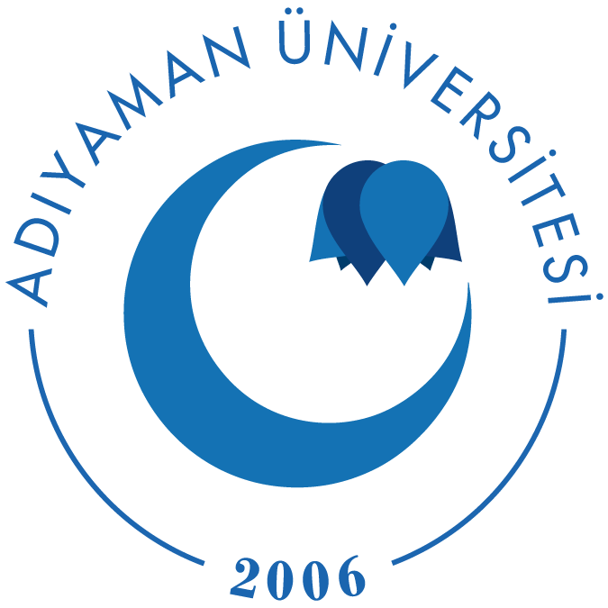

ADIYAMAN UNIVERSITY
TR ADIYAMA01

CONFIRMATION OF TEACHING STAFF EXCHANGE

DETAILS OF ACADEMIC STAFF
Name and Surname of Incoming Staff
Name of the Sending University

INFORMATION ABOUT TEACHING ACTIVITIES
Faculty /Academic Unit at Host Uni.
Language of Instruction
Level of Teaching | ( ) Pre-degree  ( ) Degree / Bachelor  ( ) Masters  ( ) Doctorate
Dates | From .../.../ 20 to .../.../20
Teaching Days in Total
Teaching Hours in Total

Departmental  Erasmus Coordinator | Date and Place | Stamp
Name and Signature | ..../..../200  Adıyaman

